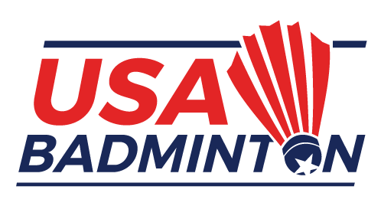
USA BADMINTON Technical officials
advisory group

Officiating Documentation Card for 2023

This card must be submitted to the USA Badminton Technical Officials Advisory Group (TOAG) before January 31, 2024 to assist in formulating the active status list of US Court Officials. An evaluation of officiating activities for 2023 will be made by the COC and a determination of active status for 2024 will be made at that time.
Name:
Home Address:
Work Address: |  |  | City | State | Zip
Home Phone: |  | Work Phone: | City | State | Zip
Cell Phone: |  | Email:

Certification Level: | Regional: |  | National: |  | Pan Am: |  | BWF:

OFFICIATING ACTIVITY: JANUARY 1, 2023, THROUGH DECEMBER 31, 2023

Total Number of Matches as:
Date |  | Tournament Name/Location |  | Referee |  | Umpire |  | Service  Judge |  | Lines Judge |  | Signature of Tournament Director, Referee or Coordinator*
 |  | TOTALS:

_____________________________________________
Signature of Named Individual

Scan and return this card to Ian Counter by email at: ICOUNTER@GMAIL.COM

(*) The Tournament Director/Referee or Line Judge Coordinator signature must be original and legible, or a Tournament Report summary should be provided.

