Request for Proposal


2025 YONEX USA BADMINTON
Adult National Championship
Host Site Proposal
This document features a comprehensive proposal outlining the host site sponsorship of the future YONEX USA Badminton Adult National Championships. The deadline to submit an RFP is September 25, 2025.

EVENT BACKGROUND:

The YONEX U.S. Adult National Championship is held in December with 100+ participants traveling from all across the United States to participate in this annual premier tournament which spans four days of competition play. This event generally attracts the highest level of U.S. athletes to compete. Events include Men’s Singles, Men’s Doubles, Women’s Singles, Women’s Doubles, and Mixed Doubles. The event has generally been used as the Selection Event for the U.S. team that will represent in the Pan Am continental team championships.
While the YONEX Adult National Championships will be centered on competition for the nation’s best badminton players, there are also plans for the event to include clinics and seminars for athletes, coaches, and officials, as well as social events such as a banquet or ice cream social.
Badminton advisory groups and committees may schedule to hold their annual in-person meetings in conjunction with the event, such as the Board of Directors, the Junior Advisory Group, and the Technical Officials Advisory Group. The USA Badminton Annual General Assembly is also typically held at the event either between play or at the end of play.
Available Event Dates:

2025, 2026, 2027, 2028

VENUE REQUIREMENTS:

- Competition Area: A gymnasium/arena/convention center/badminton facility with space for at least 5 regulation badminton courts and seating capacity of at least 100 is preferred.
Court Space
Four to ten (4-10) courts may be needed. The typical layout for four (4) badminton courts is a total of 120' x 60' (single court size = 20' x 44’). At least six (6) feet of space is required between courts providing ample space for line judges, umpire and referee chairs, scoreboards, etc.

Lighting
It is highly recommended for the proposed venue to have at least 150-foot candles of light on the participation surface for video streaming and/or television broadcast.

Background light should be eliminated. Any source of lighting behind the ends of the courts, such as a doorway, a window or a light fixture, can interfere with the tracking of a shuttle in flight. Windows should be fitted with dark colored shutters or curtains. Walls should be dark colored and ideally have a textured surface in order to minimize reflection of light.

Flooring
Badminton court mats are preferred. The base surface the court mats will be laid out on (wood, synthetics, sport tile, etc.) must have a degree of "springiness." If the base floor is concrete, alternative flooring will need to be laid between the concrete and the badminton court mats.

Ceiling Height
The facility should have a minimum unobstructed ceiling height clearance of at least thirty (30) feet.

Equipment
The necessary nets, poles, and umpire chairs are also required for each court. The CVB/venue may need to help supply additional equipment. The venue should have an area with enough space for multiple tables to serve as the tournament desk.

Other Items to Consider
HVAC (airflow cannot impact competition)
Colored ceiling and walls
Venue lighting (positioning of lights - impacting play)

- A physician or emergency medically trained individual must be on site during play. At least one (1) massage tables should be set up near the field of play at the medical area. A portable defibrillator on premises is required.
- The following rooms may be needed for the event:
- Training/Warmup Room or Area for athletes to warm up and prepare for their next matches either within the competition area or adjacent to. Also used for taping, physical therapy, and additional on-site medical care as needed.
- Concession Area - A concession area should be close to, but not part of the playing area with vegetarian and Asian food options to cater to the badminton community. Alternatively, there should be restaurants nearby in the area.
- Waivers to above criteria will be considered on a case-by-case basis.

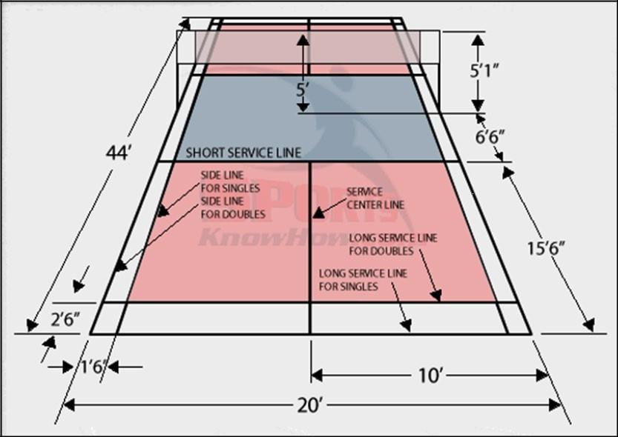

Equipment in the venue:
- Work station (computer)
- Printer / Copy machine (with supply of ink / toner and paper)
- Internet and power access for the tournament desk area
- Public Announcement Sound equipment and microphone, with ability to link a phone or computer

MEETING SPACE / ROOM NEEDS:

Meeting space will be needed during the tournaments. On each day of the event meeting space will be needed to accommodate a minimum of 20-30 individuals with a screen or projector. This space will be for coaches, technical officials, and any other advisory group or committee that will meet during the event. AV will be needed.
Hospitality space will be needed for staff and officials set up with soft drinks, snack foods, sandwiches, hot beverages, etc. This can be part of the competition floor (separated with pipe and drape) or a separate area.

EVENT OPERATIONS:

USA Badminton owns and operates the event. Depending on the agreement with the host, USA Badminton may provide the tournament staff to work the event while collaborating with the CVB, Sports Commission, and the local badminton community to secure volunteers for any roles not filled by tournament staff. Engaging the local club(s) and/or participant(s) is strongly recommended.
Daily volunteer needs are as follows:
- Tournament operations roles, such as staging area, warm-up area, check-in desks, shuttle control
- Potential shuttle drivers from airport to hotel
- Local USAB certified umpires (USAB will train prior to tournament)
Each facility may require additional volunteer support which can be addressed in the planning process.
USA Badminton retains 33% of the revenue generated for the event (USA Badminton sponsors, ticketing, program sales, vendor expo booths, event merchandise, etc.). USA Badminton will allow host to sell local sponsorships for the event, providing that they do not conflict with USA Badminton existing sponsors. This would also include booth space at the vendor expo.
USA BADMINTON SITE SELECTION CRITERIA:
The investment is the total required for the 2025, 2026, 2027, or 2028 contractual agreement:

- Venue Rental and meeting room costs at venue or host hotel
- Temporary spectator seating, table/furniture rental at the event.
- Temporary Signs, banners, barriers at event.
- Temporary sub-flooring and flooring/tiles/mats necessary to conduct the event
- Production cost including rigging, staging, sound, and lighting associated with the event.
- Production of credentials for the event
- Production of promotional items, materials, and merchandise created specifically for the event
- Cost of a photographer, videographer, or streaming that documents the event
- Hospitality needs at the venue
- Food and non-alcoholic beverages, the provision of which is directly related to the event and that is provided on-site at the event for staff, volunteers, officials, referees, and coaches.
- Water
- Compensation for referees, judges, officials, and non-health staff hired to meet the objective of the event.
- Lodging costs, meals, car rental and automobile mileage cost up to the allowable rates for state employees for staff, volunteers, referees, and officials during the event.
- Airfare costs up to the regular published rates for coach class on a commercial airline.
- Ground transportation costs for staff, volunteers, officials, referees.
- Staff/officials/volunteer uniforms
- Volunteer support for event
- Cost of non-monetary prizes, trophies, plaques at the event.
- Site-visit expenses (two USA Badminton representatives to visit the proposed venue before the bid is awarded. Flight, Hotel, Rental Car)
- Event travel expenses for USA Badminton staff - 10 rooms and 2 rental cars for 8 days
- Police, Security, EMT and Athletic Trainers including stand-by services on site for the public health or safety of all attendees, officials, volunteers, coaches, and athletes.

USA BADMINTON SITE SELECTION CRITERIA:

USA Badminton will use the following guidelines in the selection process.
- Venue: Proximity to hotels, proper set up, quality of the facility
- Hotels: Adequate number of rooms (doubles), rate, amenities and location
- Uniqueness: What sets host site apart, special amenities, attractions, etc.
- Host Financial Contributions

PROPOSAL BID:

The following are the items that should be included with your bid proposal. Please submit your bid proposal with the details necessary to cover the following information:

Introduction
- Description of the host community and what sets your community apart from others.
- An outline on how the host will get the community to embrace the event.
- Summary of past events that have been hosted in your community.
- Explain the typical weather patterns that occur in your community this time of year.

Financial
- Please confirm your ability to accept the investment obligations listed in the Host Investment Requirements section (✓).
- Please present a fulfillment structure for the investment obligations. Outline how the host will fulfill the investment obligations for this event?

Facility Information
Competition Venue Information (please submit exterior and interior photographs in addition to a facility diagram showing floor plans, height, seating, entrances/exits, adjacent rooms and areas etc.).
  - Name of Venue:
  - Address of Facility:
  - Contact person:
  - Phone: Email:
  - Square Footage: Type of Floor:
  - Type of court markings on floor space? (Badminton, Basketball, Volleyball etc.):
  - Is Facility air-conditioned? Can air-condition be turned off?
  - Type of lighting:
  - Number of Feet-candles: Height of Ceiling: Maximum # of Courts:

Adjacent Facilities/Rooms/Specific Areas
  - Restrooms and Locker Rooms
  - Meeting Rooms
  - Trainer/Medical Room
  - Concession Area
  - Merchandise Sales / Vendor Booth Area
  - Hospitality Room / Player’s Lounge
  - Parking / Number of spaces
  - Parking Fees (if any)
  - Locked Storage Rooms (Equipment, etc.)

Equipment
  - Wireless Internet Access
  - Copy Machine
  - PA / Sound System

Seating
  - Seating Capacity
  - Seating Type (bleachers, portable, chair back, etc.)

Accommodation
- Host Hotel & Over-Flow Properties:
- Detail the amenities of the property, example: Restaurants, swimming pool, workout facility, business center etc.
- Distance from hotel(s) to venue.
- Distance from hotel(s) to primary airport.
- Proposed rates and number of single/double rooms available
- Does rate include breakfast, internet, parking, etc.

Transportation
- Airlines that service the airport
- Any shuttle or public transportation information
- Rental car providers

SUBMISSION INSTRUCTIONS:
RFP Deadline: September 25, 2025 at 11:59 PM Pacific for 2025 event
Electronic bids should be e-mailed to Trenton Szeto on, or before, the submission deadline. Please e-mail bids to Trenton.Szeto@usabadminton.org

